

Compensation and Pension Record Interchange (CAPRI)

Hematologic and Lymphatic Conditions, including Leukemia

Disability Benefits Questionnaire (DBQ)

Workflow

April 2011

Department of Veterans Affairs
Office of Enterprise Development
Management & Financial Systems

Revision History

Date | Description (Patch # if applicable) | Author | Technical Writer
11/11/2010 | Document created for Patch 161. | C. Gawronski | N/A
1/25/2011 | Minor corrections | M. Guthrie | N/A
4/1/2011 | Changes for Patch 163 | M. Guthrie | N/A

Table of Contents

1 Introduction 1
1.1 Purpose 1
1.2 Overview 1
2 Hematologic and Lymphatic Conditions DBQ 2
2.1 Name of patient/Veteran 2
2.2 Section 1. Diagnosis 3
2.3 Section 2. Medical history 9
2.4 Section 3. Treatment 10
2.5 Section 4. Conditions, complications and/or residuals 17
2.6 Section 5. Recurring infections 21
2.7 Section 6. Thrombocytopenia (primary, idiopathic or immune) 22
2.8 Section 7. Polycythemia vera 24
2.9 Section 8. Sickle cell anemia 26
2.10 Section 9. Other pertinent physical findings, complications, conditions, signs and/or symptoms 27
2.11 Section 10. Diagnostic testing 29
2.12 Section 11. Functional impact 31
2.13 Section 12. Remarks, if any 33
3 Hemic and Lymphatic DBQ-AMIE Worksheet 34

Table of Figures and Tables

Figure 1: Template Example: DBQ - Standard VA Note 1
Figure 2: Print Example: DBQ – Standard VA Note 1
Figure 3: Template Example: DBQ – Hemic and Lymphatic – Name of patient/Veteran 2
Figure 4: Print Example: DBQ – Hemic and Lymphatic – Name of patient/Veteran 2
Figure 5: Template Example: DBQ – Hemic and Lymphatic – 1. Diagnosis 8
Figure 6: Print Example: DBQ – Hemic and Lymphatic – 1. Diagnosis 9
Figure 7: Template Example: DBQ – Hemic and Lymphatic – 2. Medical history 10
Figure 8: Print Example: DBQ – Hemic and Lymphatic – 2. Medical history 10
Figure 9: Template Example: DBQ – Hemic and Lymphatic – 3. Treatment 15
Figure 10: Print Example: DBQ – Hemic and Lymphatic – 3. Treatment 17
Figure 11: Template Example: DBQ – Hemic and Lymphatic – 4. Conditions, complications and/or residuals 20
Figure 12: Print Example: DBQ – Hemic and Lymphatic – 4. Conditions, complications and/or residuals 20
Figure 13: Template Example: DBQ – Hemic and Lymphatic – 5. Recurring infections 21
Figure 14: Print Example: DBQ – Hemic and Lymphatic – 5. Recurring infections 21
Figure 15: Template Example: DBQ – Hemic and Lymphatic – 6. Thrombocytopenia (primary, idiopathic or immune) 23
Figure 16: Print Example: DBQ – Hemic and Lymphatic – 6. Thrombocytopenia (primary, idiopathic or immune) 24
Figure 17: Template Example: DBQ – Hemic and Lymphatic – 7. Polycythemia vera 25
Figure 18: Print Example: DBQ – Hemic and Lymphatic – 7. Polycythemia vera 25
Figure 19: Template Example: DBQ – Hemic and Lymphatic – 8. Sickle cell anemia 27
Figure 20: Print Example: DBQ – Hemic and Lymphatic – 8. Sickle cell anemia 27
Figure 21: Template Example: DBQ – Hemic and Lymphatic – 9. Other pertinent physical findings, complications, conditions, signs and/or symptoms 28
Figure 22: Print Example: DBQ – Hemic and Lymphatic – 9. Other pertinent physical findings, complications, conditions, signs and/or symptoms 29
Figure 23: Template Example: DBQ – Hemic and Lymphatic – 10. Diagnostic testing 31
Figure 24: Print Example: DBQ – Hemic and Lymphatic – 10. Diagnostic testing 31
Figure 25: Template Example: DBQ – Hemic and Lymphatic – 11. Functional impact 32
Figure 26: Print Example: DBQ – Hemic and Lymphatic – 11. Functional impact 32
Figure 27: Template Example: DBQ – Hemic and Lymphatic – 12. Remarks, if any 33
Figure 28: Print Example: DBQ – Hemic and Lymphatic – 12. Remarks, if any 33

Table 1: Rules: DBQ – Hemic and Lymphatic – Name of patient/Veteran 2
Table 2: Rules: DBQ – Hemic and Lymphatic – 1. Diagnosis 3
Table 3: Rules: DBQ – Hemic and Lymphatic – 2. Medical history 10
Table 4: Rules: DBQ – Hemic and Lymphatic – 3. Treatment 11
Table 5: Rules: DBQ – Hemic and Lymphatic – 4. Conditions, complications and/or residuals 18
Table 6: Rules: DBQ – Hemic and Lymphatic – 5. Recurring infections 21
Table 7: Rules: DBQ – Hemic and Lymphatic – 6. Thrombocytopenia (primary, idiopathic or immune) 23
Table 8: Rules: DBQ – Hemic and Lymphatic – 7. Polycythemia vera 25
Table 9: Rules: DBQ – Hemic and Lymphatic – 8. Sickle cell anemia 26
Table 10: Rules: DBQ – Hemic and Lymphatic – 9. Other pertinent physical findings, complications, conditions, signs and/or symptoms 28
Table 11: Rules: DBQ – Hemic and Lymphatic – 10. Diagnostic testing 30
Table 12: Rules: DBQ – Hemic and Lymphatic – 11. Functional impact 32
Table 13: Rules: DBQ – Hemic and Lymphatic – 12. Remarks, if any 33

Introduction

Purpose
This document provides a high level overview of the contents found on the Hematologic and Lymphatic Conditions, including Leukemia Disability Benefits Questionnaire (DBQ). The DBQ can be populated via an online template within the CAPRI C&P Worksheets tab and then printed OR it can be printed via AMIE (AUTOMATED MEDICAL INFORMATION EXCHANGE) and then manually populated. This document contains the edit rules for the template as well as an example of how the template will look online in CAPRI or printed from CAPRI. It also contains the layout for the AMIE worksheet to depict how it will look when printed from AMIE.

For more detailed information on standard template functionality not covered in this document, please refer to the C&P Worksheet Tab Functionalities section of the CAPRI GUI User Guide.

Overview
The Hematologic and Lymphatic Conditions, including Leukemia DBQ provides the ability to capture information related to Hematologic and Lymphatic Conditions (including Leukemia) and its treatment.

Each DBQ template contains a standard footer containing a note stating that “VA may request additional medical information, including additional examinations if necessary to complete VA’s review of the Veteran’s application.” (see Figure 1 and 2).

Figure 1: Template Example: DBQ - Standard VA Note
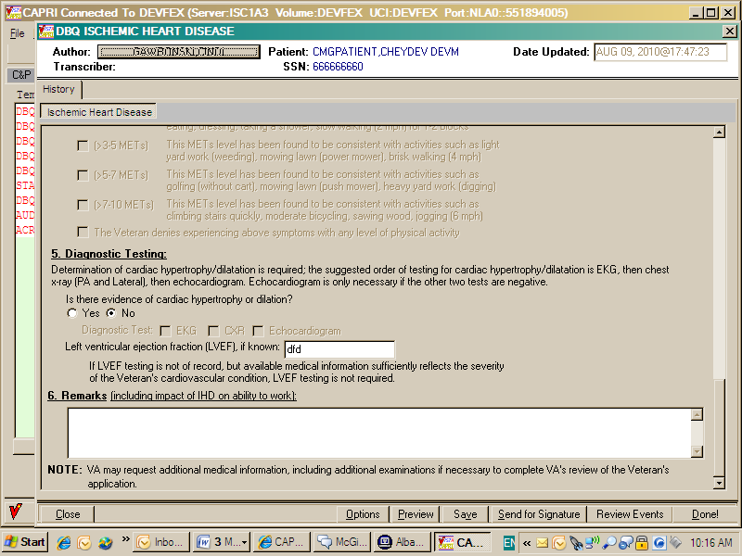

Figure 2: Print Example: DBQ – Standard VA Note

NOTE: VA may request additional medical information, including additional

examinations if necessary to complete VA's review of the Veteran's application.

A number of fields on the Hematologic and Lymphatic Conditions template are mandatory and require a response (value) prior to the exam being marked as completed. Some questions may activate a Pop-up window displaying information as to each question that needs to be answered before the template can be completed.

Hematologic and Lymphatic Conditions DBQ

Name of patient/Veteran
All questions in this section may be answered as described by the rules below. If all mandatory questions are not answered, the error message(s) will appear in a popup window as depicted below.

Table 1: Rules: DBQ – Hemic and Lymphatic – Name of patient/Veteran
Field/Question | Field Disposition | Valid Values | Format | Error Message
Hematologic and Lymphatic Conditions,  including Leukemia | Enabled, Read-Only | N/A | N/A | N/A
Disability Benefits Questionnaire | Enabled, Read-Only | N/A | N/A | N/A
Name of patient/Veteran: | Enabled, Mandatory | N/A | Free Text | Please enter the name of the patient/Veteran.
Your patient is applying to the U. S. Department of Veterans Affairs (VA) for disability benefits. VA will consider the information you provide on this questionnaire as part of their evaluation in processing the Veteran’s claim. | Enabled, Read-Only | N/A | N/A | N/A

Figure 3: Template Example: DBQ – Hemic and Lymphatic – Name of patient/Veteran
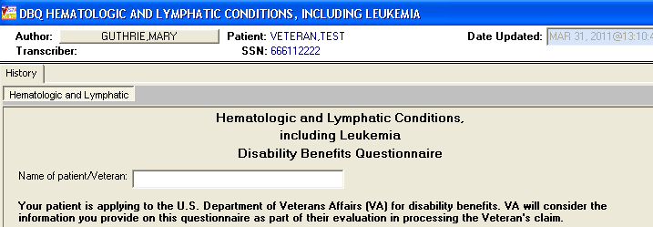

Figure 4: Print Example: DBQ – Hemic and Lymphatic – Name of patient/Veteran
Hematologic and Lymphatic Conditions,
including Leukemia
Disability Benefits Questionnaire
Name of patient/Veteran:
Your patient is applying to the U.S. Department of Veterans Affairs (VA) for
disability benefits. VA will consider the information you provide on this
questionnaire as part of their evaluation in processing the Veteran's claim.

Section 1. Diagnosis
The question “Does the Veteran now have or has he/she ever been diagnosed with a hematologic and/or lymphatic condition?” must be answered before the template can be completed.

- If it is answered with Yes, all other questions requiring an answer as described by the rules in this document must be answered before the template can be completed.
- If it is answered with No, the rationale supporting this is required. The remainder of the template may be completed without answering any additional questions or the user may input answers to any of the optional questions as indicated by the rules described in this document.

All questions will be printed even if they have not been answered.

If all mandatory questions are not answered, the error message(s) will appear in a popup window as depicted below and must be answered before this template can be completed.

Table 2: Rules: DBQ – Hemic and Lymphatic – 1. Diagnosis
Field/Question | Field Disposition | Valid Values | Format | Error Message
1.Diagnosis | Enabled, Read-Only | N/A | N/A | N/A
Does the Veteran now have or has he/she ever been diagnosed with a hematologic and/or lymphatic condition? | Enabled, Mandatory, Choose one valid value | [Yes; No] | N/A | Please answer the question: Does the Veteran now have or has he/she ever been diagnosed with a hematologic and/or lymphatic condition?
If no, provide rationale (e.g., Veteran does not currently have any known hematologic or lymphatic condition(s)): | If Diagnosis = No; Enabled, Mandatory  Else; Disabled | N/A | Free Text | Please provide the rationale for stating the Veteran has never been diagnosed with a hematologic and/or lymphatic condition.

If yes, select the Veteran’s condition: | If Diagnosis = Yes; Enabled, Mandatory, Choose one or more valid values  Else; Disabled | [Acute lymphocytic leukemia (ALL);  Acute myelogenous leukemia (AML);  Chronic myelogenous leukemia (CML);  Hodgkin’s disease;  Non-Hodgkin’s lymphoma;  Anemia;  Thrombocytopenia;  Polycythemia vera;  Sickle cell anemia;  Splenectomy;  Hairy cell or other B-cell leukemia: If checked, complete Hairy cell and other B-cell leukemias Questionnaire.;  Other hematologic or lymphatic condition(s):] | N/A | Please select the Veteran's condition.
Acute lymphocytic leukemia (ALL) ICD code: | If Acute lymphocytic leukemia (ALL) = Yes; Enabled, Mandatory  Else; Disabled | N/A | Free Text | Please enter the ICD code for Acute lymphocytic leukemia (ALL).
Acute lymphocytic leukemia (ALL) Date of diagnosis: | If Acute lymphocytic leukemia (ALL) = Yes; Enabled, Mandatory  Else; Disabled | N/A | Free Text | Please enter the date of diagnosis for Acute lymphocytic leukemia (ALL).
Acute myelogenous leukemia (AML) ICD code: | If Acute myelogenous leukemia (AML) = Yes; Enabled, Mandatory  Else; Disabled | N/A | Free Text | Please enter the ICD code for Acute myelogenous leukemia (AML).
Acute myelogenous leukemia (AML)  Date of diagnosis: | If Acute myelogenous leukemia (AML) = Yes; Enabled, Mandatory  Else; Disabled | N/A | Free Text | Please enter the date of diagnosis for Acute myelogenous leukemia (AML).
Chronic myelogenous leukemia (CML) ICD code: | If Chronic myelogenous leukemia (CML) = Yes; Enabled, Mandatory  Else; Disabled | N/A | Free Text | Please enter the ICD code for Chronic myelogenous leukemia (CML).
Chronic myelogenous leukemia (CML) Date of diagnosis: | If Chronic myelogenous leukemia (CML) = Yes; Enabled, Mandatory  Else; Disabled | N/A | Free Text | Please enter the date of diagnosis for Chronic myelogenous leukemia (CML).
Hodgkin’s disease ICD code: | If Hodgkin’s disease = Yes; Enabled, Mandatory  Else; Disabled | N/A | Free Text | Please enter the ICD code for Hodgkin's disease.
Hodgkin’s disease Date of diagnosis: | If Hodgkin’s disease = Yes; Enabled, Mandatory  Else; Disabled | N/A | Free Text | Please enter the date of diagnosis for Hodgkin's disease.
Non-Hodgkin’s lymphoma ICD code: | If Non-Hodgkin’s lymphoma = Yes; Enabled, Mandatory  Else; Disabled | N/A | Free Text | Please enter the ICD code for Non-Hodgkin's lymphoma.
Non-Hodgkin’s lymphoma Date of diagnosis: | If Non-Hodgkin’s lymphoma = Yes; Enabled, Mandatory  Else; Disabled | N/A | Free Text | Please enter the date of diagnosis for Non-Hodgkin's lymphoma.
Anemia ICD code: | If Anemia = Yes; Enabled, Mandatory  Else; Disabled | N/A | Free Text | Please enter the ICD code for Anemia.
Anemia Date of diagnosis: | If Anemia = Yes; Enabled, Mandatory  Else; Disabled | N/A | Free Text | Please enter the date of diagnosis for Anemia.
Thrombocytopenia ICD code: | If Thrombocytopenia = Yes; Enabled, Mandatory  Else; Disabled | N/A | Free Text | Please enter the ICD code for Thrombocytopenia.
Thrombocytopenia Date of diagnosis: | If Thrombocytopenia = Yes; Enabled, Mandatory  Else; Disabled | N/A | Free Text | Please enter the date of diagnosis for Thrombocytopenia.
Polycythemia vera ICD code: | If Polycythemia vera = Yes; Enabled, Mandatory  Else; Disabled | N/A | Free Text | Please enter the ICD code for Polycythemia vera.
Polycythemia vera Date of diagnosis: | If Polycythemia vera = Yes; Enabled, Mandatory  Else; Disabled | N/A | Free Text | Please enter the date of diagnosis for Polycythemia vera.
Sickle cell anemia ICD code: | If Sickle cell anemia = Yes; Enabled, Mandatory  Else; Disabled | N/A | Free Text | Please enter the ICD code for Sickle cell anemia.
Sickle cell anemia Date of diagnosis: | If Sickle cell anemia = Yes; Enabled, Mandatory  Else; Disabled | N/A | Free Text | Please enter the date of diagnosis for Sickle cell anemia.
Splenectomy ICD code: | If Splenectomy = Yes; Enabled, Mandatory  Else; Disabled | N/A | Free Text | Please enter the ICD code for Splenectomy.
Splenectomy Date of diagnosis: | If Splenectomy = Yes; Enabled, Mandatory  Else; Disabled | N/A | Free Text | Please enter the date of diagnosis for Splenectomy.
Other diagnosis #1: | If Other hematologic or lymphatic condition(s)= Yes; Enabled, Mandatory  Else; Enabled, Optional | N/A | Free Text | Please enter a value in the 'Other diagnosis #1' field.
ICD code: | If Other hematologic or lymphatic condition(s) = Yes; Enabled, Mandatory  Else; Enabled , Optional | N/A | Free Text | Please enter the ICD code for other diagnosis #1.
Date of diagnosis: | If Other hematologic or lymphatic condition(s) = Yes; Enabled, Mandatory  Else; Enabled, Optional | N/A | Free Text | Please enter the date of diagnosis for other diagnosis #1.
Other diagnosis #2: | Enabled, Optional | N/A | Free Text | N/A
ICD code: | If Other diagnosis #2 is populated and Diagnosis = Yes; Enabled, Mandatory  Else; Enabled, Optional | N/A | Free Text | Please enter the ICD code for other diagnosis #2.
Date of diagnosis: | If Other diagnosis #2 is populated and Diagnosis = Yes; Enabled, Mandatory  Else; Enabled, Optional | N/A | Free Text | Please enter the date of diagnosis for other diagnosis #2.
Other diagnosis #3: | Enabled, Optional | N/A | Free Text | N/A
ICD code: | If Other diagnosis #3 is populated and Diagnosis = Yes; Enabled, Mandatory  Else; Enabled, Optional | N/A | Free Text | Please enter the ICD code for other diagnosis #3.
Date of diagnosis: | If Other diagnosis #3 is populated and Diagnosis = Yes; Enabled, Mandatory  Else; Enabled, Optional | N/A | Free Text | Please enter the date of diagnosis for other diagnosis #3.
If there are additional diagnoses that pertain to hematologic or lymphatic condition(s), list using above format: | Enabled, Optional | N/A | Free Text | N/A

Figure 5: Template Example: DBQ – Hemic and Lymphatic – 1. Diagnosis
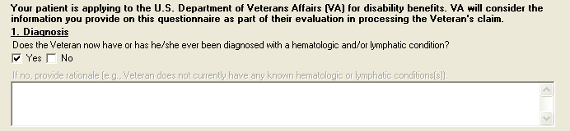
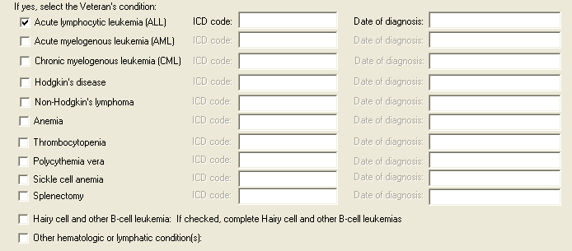
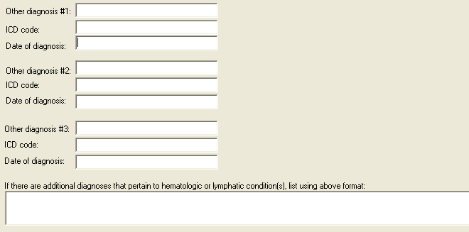

Figure 6: Print Example: DBQ – Hemic and Lymphatic – 1. Diagnosis

1. Diagnosis
------------
Does the Veteran now have or has he/she ever been diagnosed with a
hematologic and/or lymphatic condition? [X] Yes [ ] No
If no, provide rationale (e.g., Veteran does not currently have any known
hematologic or lymphatic conditions(s)):
If yes, select the Veteran's condition:
[X] Acute lymphocytic leukemia (ALL)
ICD code: Date of diagnosis:
[ ] Acute myelogenous leukemia (AML)
ICD code: Date of diagnosis:
[ ] Chronic myelogenous leukemia (CML)
ICD code: Date of diagnosis:
[ ] Hodgkin's disease
ICD code: Date of diagnosis:
[ ] Non-Hodgkin's lymphoma
ICD code: Date of diagnosis:
[ ] Anemia
ICD code: Date of diagnosis:
[ ] Thrombocytopenia
ICD code: Date of diagnosis:
[ ] Polycythemia vera
ICD code: Date of diagnosis:
[ ] Sickle cell anemia
ICD code: Date of diagnosis:
[ ] Splenectomy
ICD code: Date of diagnosis:
[ ] Hairy cell and other B-cell leukemia: If checked, complete Hairy
cell and other B-cell leukemias Questionnaire.
[ ] Other hematologic or lymphatic condition(s):
Other diagnosis #1:
ICD code:
Date of diagnosis:
Other diagnosis #2:
ICD code:
Date of diagnosis:
Other diagnosis #3:
ICD code:
Date of diagnosis:
If there are additional diagnoses that pertain to hematologic or
lymphatic condition(s), list using above format:

Section 2. Medical history
All questions in this section may be answered as described by the rules below. If all mandatory questions are not answered, the error message(s) will appear in a popup window as depicted below.

Table 3: Rules: DBQ – Hemic and Lymphatic – 2. Medical history
Field/Question | Field Disposition | Valid Values | Format | Error Message
2.Medical history | Enabled, Read Only | N/A | N/A | N/A
a. Describe the history (including onset, course and status) of the Veteran’s current condition(s) (brief summary): | If Diagnosis = Yes and a condition is selected in the Diagnosis section; Enabled, Mandatory  Else; Enabled, Optional | N/A | Free Text | Please describe the history (including onset and course) of the Veteran's current condition(s).
b. Indicate the status of the primary condition: | If Diagnosis = Yes and a condition is selected in the Diagnosis section; Enabled, Mandatory, Choose one valid value  Else; Enabled, Optional | [Active;  Remission;  Not applicable] | N/A | Please indicate the status of the disease.

Figure 7: Template Example: DBQ – Hemic and Lymphatic – 2. Medical history
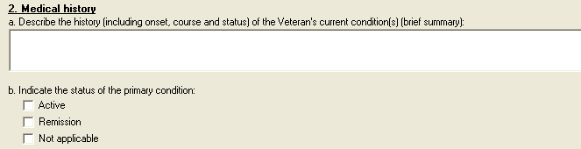

Figure 8: Print Example: DBQ – Hemic and Lymphatic – 2. Medical history
2. Medical history
------------------
a. Describe the history (including onset, course and status) of the
Veteran's current condition(s) (brief summary):
b. Indicate the status of the primary condition:
[ ] Active
[ ] Remission
[ ] Not applicable

Section 3. Treatment
All questions in this section may be answered as described by the rules below. If all mandatory questions are not answered, the error message(s) will appear in a popup window as depicted below.

Table 4: Rules: DBQ – Hemic and Lymphatic – 3. Treatment
Field/Question | Field Disposition | Valid Values | Format | Error Message
3.Treatment | Enabled, Read Only | N/A | N/A | N/A
a. Has the Veteran completed any treatment or is the Veteran currently undergoing any treatment for any lymphatic or hematologic condition, including leukemia? | If Diagnosis = Yes and a condition is selected in the Diagnosis section; Enabled, Mandatory, Choose one valid value  Else; Enabled, Optional | [Yes; No, watchful waiting] | N/A | Please answer the question: Has the Veteran completed any treatment or is the Veteran currently undergoing any treatment for any lymphatic or hematologic condition, including leukemia?
If yes, indicate treatment type(s) (check all that apply): | If the previous question = Yes; Enabled, Mandatory; Choose one or more valid values  Else; Disabled | [Treatment completed, currently in watchful waiting status;  Bone marrow transplant ;  Surgery; Radiation therapy ;  Antineoplastic chemotherapy;  Other therapeutic procedure and/or treatment (describe):] | Free Text | Please check at least one applicable treatment type.
Date of hospital admission and location: | If treatment types include Bone marrow transplant; Enabled, Mandatory  Else; Disabled | N/A | Free Text | For the bone marrow transplant, please provide the date of hospital admission and location.
Date of hospital discharge after transplant: | If treatment types include Bone marrow transplant; Enabled, Mandatory  Else; Disabled | N/A | Free Text | For the bone marrow transplant, please provide the date of hospital discharge after transplant.
If checked, describe: | If treatment type includes Surgery; Enabled, Mandatory  Else; Disabled | N/A | Free Text | Please describe the surgical procedure performed.
Date(s) of surgery: | If treatment types include Surgery; Enabled, Mandatory  Else; Disabled | N/A | Free Text | Please enter the date of surgery.
Date of most recent treatment: | If treatment types include Radiation therapy;  Enabled, Mandatory  Else; Disabled | N/A | Free Text | Please enter the date of the most recent radiation therapy treatment.
Date of completion of treatment or anticipated date of completion: | If treatment types include Radiation therapy; Enabled, Mandatory  Else; Disabled | N/A | Free Text | Please enter the radiation therapy's date of completion (actual or anticipated).
Date of most recent treatment: | If treatment types include Antineoplastic chemotherapy; Enabled, Mandatory  Else; Disabled | N/A | Free Text | Please enter the date of the most recent antineoplastic chemotherapy treatment.
Date of completion of treatment or anticipated date of completion: | If treatment types include Antineoplastic chemotherapy; Enabled, Mandatory  Else; Disabled | N/A | Free Text | Please enter the antineoplastic chemotherapy treatment's date of completion (actual or anticipated).
Other therapeutic procedure and/or treatment (describe): | If treatment types include Other therapeutic procedure and/or treatment; Enabled, Mandatory  Else; Disabled | N/A | Free Text | Please describe the other therapeutic procedure and/or treatment performed.
Date of procedure: | If treatment types include Other therapeutic procedure and/or treatment; Enabled, Mandatory  Else; Disabled | N/A | Free Text | Please enter the date of the most recent other therapeutic procedure and/or treatment.
Date of completion of treatment or anticipated date of completion: | If treatment types include Other therapeutic procedure and/or treatment; Enabled, Mandatory  Else; Disabled | N/A | Free Text | Please enter the date of completion (actual or anticipated) of the other therapeutic procedure and/or treatment.
b. Does the Veteran have anemia, including anemia caused by treatment for a hematologic or lymphatic condition? | If Diagnosis = Yes and a condition is selected in the Diagnosis section; Enabled, Mandatory, Choose one valid value  Else; Enabled, Optional | [Yes; No] | N/A | Please answer the question: Does the Veteran have anemia, including anemia caused by treatment for a hematologic or lymphatic condition?
(If “yes”, answer both questions 3.b.i and 3.b.ii) | If Does the Veteran have anemia, including anemia caused by treatment for a hematologic or lymphatic condition? = Yes; Enabled, Read-Only  Else; Disabled | N/A | N/A | N/A
i. Is the anemia caused secondary to treatment of another hematologic or lymphatic condition? | If Does the Veteran have anemia, including anemia caused by treatment for a hematologic or lymphatic condition?= Yes; Enabled, Mandatory  Choose one valid value  Else; Disabled | [Yes; No] | N/A | Please answer the question: Is the anemia caused secondary to treatment of another hematologic or lymphatic condition?
If yes, provide the name of the other condition: | If Is the anemia caused secondary to treatment of another hematologic or lymphatic condition? = Yes; Enabled, Mandatory  Else; Disabled | N/A | Free Text | Please provide the name of the other hematologic or lymphatic condition that caused the secondary anemia.
ii. Is continuous medication required for control of the anemia? | If Does the Veteran have anemia, including anemia caused by treatment for a hematologic or lymphatic condition?= Yes; Enabled, Mandatory  Choose one valid value  Else; Disabled | [Yes; No] | N/A | Please indicate whether or not continuous medication is required for control of the anemia.
If yes, list medication(s): | If Is continuous medication required for control of the anemia? = Yes; Enabled, Mandatory  Else; Disabled | N/A | Free Text | Please list medication(s) continuously needed to control anemia.
c. Does the Veteran have thrombocytopenia, including thrombocytopenia caused by treatment for a hematologic or lymphatic condition? | If Diagnosis = Yes and a condition is selected in the Diagnosis section; Enabled, Mandatory, Choose one valid value  Else; Enabled, Optional | [Yes; No] | N/A | Please answer the question: Does the Veteran have thrombocytopenia, including thrombocytopenia caused by treatment for a hematologic or lymphatic condition?
(If “yes”, answer both questions 3.c.i and 3.c.ii) | If Does the Veteran have thrombocytopenia, including thrombocytopenia caused by treatment for a hematologic or lymphatic condition? = Yes; Enabled, Read-Only  Else; Disabled | N/A | N/A | N/A
i. Is the thrombocytopenia caused secondary to treatment of another hematologic or lymphatic condition? | If Does the Veteran have thrombocytopenia, including thrombocytopenia caused by treatment for a hematologic or lymphatic condition?= Yes; Enabled, Mandatory  Choose one valid value  Else; Disabled | [Yes; No] | N/A | Please answer the question: Is the thrombocytopenia caused secondary to treatment of another hematologic or lymphatic condition?
If yes, provide the name of the other condition: | If Is the thrombocytopenia caused secondary to treatment of another hematologic or lymphatic condition?= Yes; Enabled, Mandatory  Else; Disabled | N/A | Free Text | Please provide the name of the other hematologic or lymphatic condition that caused the secondary thrombocytopenia.
ii. Is continuous medication required for control of the thrombocytopenia? | If Does the Veteran have thrombocytopenia, including thrombocytopenia caused by treatment for a hematologic or lymphatic condition?= Yes; Enabled, Mandatory  Choose one valid value  Else; Disabled | [Yes; No] | N/A | Please indicate whether or not continuous medication is required for control of the thrombocytopenia.
If yes, list medication(s): | If Is continuous medication required for control of the thrombocytopenia? = Yes; Enabled, Mandatory  Else; Disabled | N/A | Free Text | Please list medication(s) continuously needed to control thrombocytopenia.

Figure 9: Template Example: DBQ – Hemic and Lymphatic – 3. Treatment
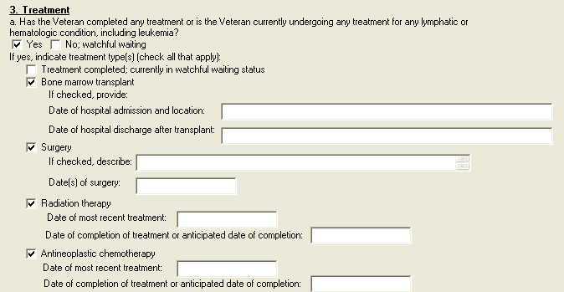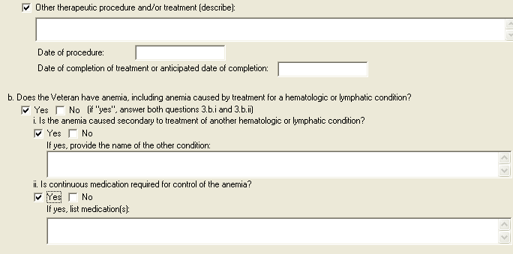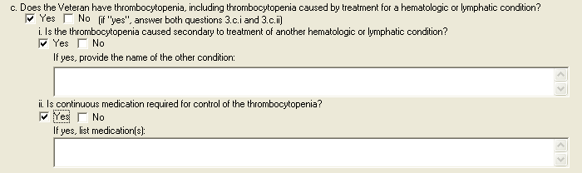

Figure 10: Print Example: DBQ – Hemic and Lymphatic – 3. Treatment
3. Treatment
------------
a. Has the Veteran completed any treatment or is the Veteran currently
undergoing any treatment for any lymphatic or hematologic condition, including
leukemia?
[X] Yes [ ] No; watchful waiting
If yes, indicate treatment type(s) (check all that apply):
[ ] Treatment completed; currently in watchful waiting status
[X] Bone marrow transplant
If checked, provide:
Date of hospital admission and location:
Date of hospital discharge after transplant:
[X] Surgery
If checked, describe:
Date(s) of surgery:
[X] Radiation therapy
Date of most recent treatment:
Date of completion of treatment or anticipated date of
completion:
[X] Antineoplastic chemotherapy
Date of most recent treatment:
Date of completion of treatment or anticipated date of
completion:
[X] Other therapeutic procedure and/or treatment (describe):
Date of procedure:
Date of completion of treatment or anticipated date of
completion:
b. Does the Veteran have anemia, including anemia caused by treatment for a
hematologic or lymphatic condition?
[X] Yes [ ] No (if "yes", answer both questions 3.b.i and 3.b.ii)
i. Is the anemia caused secondary to treatment of another hematologic
or lymphatic condition?
[X] Yes [ ] No
If yes, provide the name of the other condition:
ii. Is continuous medication required for control of the anemia?
[X] Yes [ ] No
If yes, list medication(s):
c. Does the Veteran have thrombocytopenia, including thrombocytopenia caused
by treatment for a hematologic or lymphatic condition?
[X] Yes [ ] No (if "yes", answer both questions 3.c.i and 3.c.ii)
i. Is the thrombocytopenia caused secondary to treatment of another
hematologic or lymphatic condition?
[X] Yes [ ] No
If yes, provide the name of the other condition:
ii. Is continuous medication required for control of the
thrombocytopenia?
[X] Yes [ ] No
If yes, list medication(s):

Section 4. Conditions, complications and/or residuals
All questions in this section may be answered as described by the rules below. If all mandatory questions are not answered, the error message(s) will appear in a popup window as depicted below.

Table 5: Rules: DBQ – Hemic and Lymphatic – 4. Conditions, complications and/or residuals
Field/Question | Field Disposition | Valid Values | Format | Error Message
4. Conditions, complications and/or residuals | Enabled, Read-Only | N/A | N/A | N/A
a. Does the Veteran currently have any conditions, complications and/or residuals due to a hematologic or lymphatic disorder or due to treatment for a hematologic or lymphatic disorder? | If Diagnosis = Yes and a condition is selected in the Diagnosis section; Enabled, Mandatory, Choose one valid value  Else; Enabled, Optional | [Yes; No] | N/A | Please answer the question: Does the Veteran currently have any conditions, complications and/or residuals due to a hematologic or lymphatic disorder or due to treatment for a hematologic or lymphatic disorder?
If yes, check all that apply: | If previous question is Yes; Enabled, Mandatory, Choose one or more valid values  Else; Disabled | [Weakness;  Easy fatigability;  Light-headedness;  Shortness of breath;  Headaches;  Dyspnea on mild exertion;  Dyspnea at rest;  Tachycardia;  Syncope;  Cardiomegaly;  High output congestive heart failure;  Complications or residuals of treatment requiring transfusion of platelets or red blood cells] | N/A | Please check at least one applicable condition, complication or residual.
If checked, indicate frequency: | If Does the Veteran currently have any conditions, complications and/or residuals due to a hematologic or lymphatic disorder or due to treatment for a hematologic or lymphatic disorder = Complications or residuals of treatment requiring transfusion of platelets or red blood cells; Enabled, Mandatory, Choose one valid value  Else; Disabled | [ At least once per year but less than once every 3 months;  At least once every 3 months;  At least once every 6 weeks] | N/A | Please indicate the frequency that transfusion of platelets or red blood cells is required.
b. Does the Veteran currently have any other conditions, complications and/or residuals of treatment from a hematologic or lymphatic disorder? | If Diagnosis = Yes and a condition is selected in the Diagnosis section; Enabled, Mandatory, Choose one valid value  Else; Enabled, Optional | [Yes; No] | N/A | Please answer the question: Does the Veteran currently have any other conditions, complications and/or residuals of treatment from a hematologic or lymphatic disorder?
If yes, describe (brief summary): | If previous question = Yes; Enabled, Mandatory  Else; Disabled | N/A | Free Text | Please describe any other conditions, complications and/or residuals.

Figure 11: Template Example: DBQ – Hemic and Lymphatic – 4. Conditions, complications and/or residuals
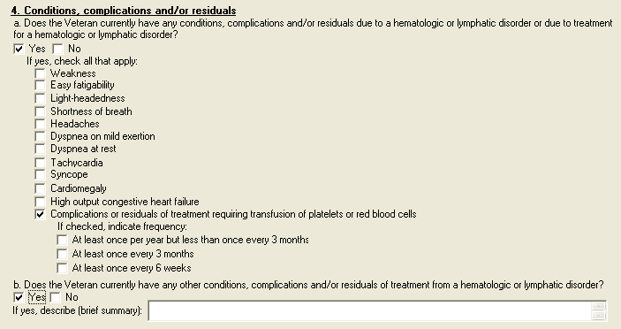

Figure 12: Print Example: DBQ – Hemic and Lymphatic – 4. Conditions, complications and/or residuals
4. Conditions, complications and/or residuals
---------------------------------------------
a. Does the Veteran currently have any conditions, complications and/or
residuals due to a hematologic or lymphatic disorder or due to treatment for a
hematologic or lymphatic disorder?
[X] Yes [ ] No
If yes, check all that apply:
[ ] Weakness
[ ] Easy fatigability
[ ] Light-headedness
[ ] Shortness of breath
[ ] Headaches
[ ] Dyspnea on mild exertion
[ ] Dyspnea at rest
[ ] Tachycardia
[ ] Syncope
[ ] Cardiomegaly
[ ] High output congestive heart failure
[X] Complications or residuals of treatment requiring transfusion of
platelets or red blood cells
If checked, indicate frequency:
[ ] At least once per year but less than once every 3 months
[ ] At least once every 3 months
[ ] At least once every 6 weeks
b. Does the Veteran currently have any other conditions, complications
and/or residuals of treatment from a hematologic or lymphatic disorder?
[X] Yes [ ] No
If yes, describe (brief summary):

Section 5. Recurring infections
All questions in this section may be answered as described by the rules below. If all mandatory questions are not answered, the error message(s) will appear in a popup window as depicted below.

Table 6: Rules: DBQ – Hemic and Lymphatic – 5. Recurring infections
Field/Question | Field Disposition | Valid Values | Format | Error Message
5. Recurring infections | Enabled, Read-Only | N/A | N/A | N/A
Does the Veteran currently have any conditions, complications and/or residuals of treatment for a hematologic or lymphatic disorder that result in recurring infections? | If Diagnosis = Yes and a condition is selected in the Diagnosis section; Enabled, Mandatory, Choose one valid value  Else; Enabled, Optional | [Yes; No] | N/A | Please answer the question: Does the Veteran currently have any conditions, complications and/or residuals of treatment for a hematologic or lymphatic disorder that result in recurring infections?
If yes, indicate frequency of infections: | If previous question = Yes; Enabled, Mandatory; Choose one valid value  Else; Disabled | [Less than once per year;  At least once per year but less than once every 3 months;  At least once every 3 months;  At least once every 6 weeks] | N/A | Please indicate the frequency of infections.

Figure 13: Template Example: DBQ – Hemic and Lymphatic – 5. Recurring infections
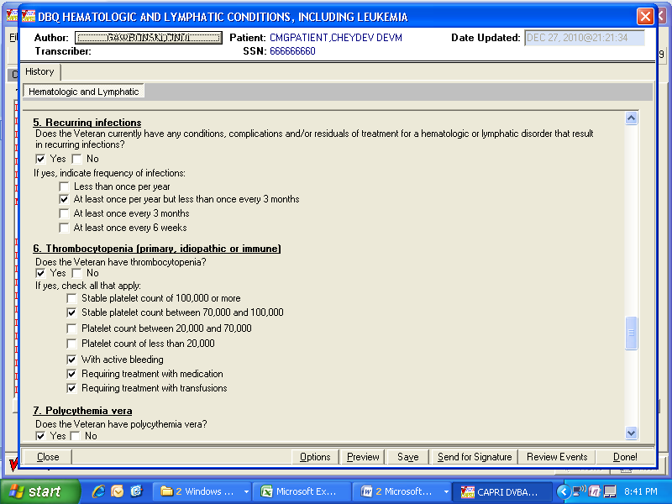

Figure 14: Print Example: DBQ – Hemic and Lymphatic – 5. Recurring infections
5. Recurring infections
-----------------------
Does the Veteran currently have any conditions, complications and/or
residuals of treatment for a hematologic or lymphatic disorder that result in
recurring infections?
[X] Yes [ ] No
If yes, indicate frequency of infections:
[ ] Less than once per year
[X] At least once per year but less than once every 3 months
[ ] At least once every 3 months
[ ] At least once every 6 weeks

Section 6. Thrombocytopenia (primary, idiopathic or immune)
All questions in this section may be answered as described by the rules below. If all mandatory questions are not answered, the error message(s) will appear in a popup window as depicted below.

Table 7: Rules: DBQ – Hemic and Lymphatic – 6. Thrombocytopenia (primary, idiopathic or immune)
Field/Question | Field Disposition | Valid Values | Format | Error Message
6. Thrombocytopenia (primary, idiopathic or immune) | If Condition = thrombocytopenia; Enabled,  Read-Only  Else; Disabled | N/A | N/A | N/A
Does the Veteran have thrombocytopenia? | If Condition = thrombocytopenia; Enabled, Mandatory, Choose one valid value  Else; Enabled, Optional | [Yes; No] | N/A | Please answer the question: Does the Veteran have thrombocytopenia?
If yes, check all that apply: | If Does the Veteran have thrombocytopenia = Yes; Enabled, Mandatory; Choose one or more valid values  Else; Disabled | [Stable platelet count of 100,000 or more;  Stable platelet count between 70,000 and 100,000;  Platelet count between 20,000 and 70,000;  Platelet count of less than 20,000;  With active bleeding;  Requiring treatment with medication;  Requiring treatment with transfusions] | N/A | Please check all applicable statements regarding the Veteran's thrombocytopenia.

Figure 15: Template Example: DBQ – Hemic and Lymphatic – 6. Thrombocytopenia (primary, idiopathic or immune)

Figure 16: Print Example: DBQ – Hemic and Lymphatic – 6. Thrombocytopenia (primary, idiopathic or immune)
6. Thrombocytopenia (primary, idiopathic or immune)
---------------------------------------------------
Does the Veteran have thrombocytopenia?
[X] Yes [ ] No
If yes, check all that apply:
[ ] Stable platelet count of 100,000 or more
[X] Stable platelet count between 70,000 and 100,000
[ ] Platelet count between 20,000 and 70,000
[ ] Platelet count of less than 20,000
[X] With active bleeding
[X] Requiring treatment with medication
[X] Requiring treatment with transfusions

Section 7. Polycythemia vera
All questions in this section may be answered as described by the rules below. If all mandatory questions are not answered, the error message(s) will appear in a popup window as depicted below.

Table 8: Rules: DBQ – Hemic and Lymphatic – 7. Polycythemia vera
Field/Question | Field Disposition | Valid Values | Format | Error Message
7. Polycythemia vera | If Condition = polycythemia vera; Enabled, Read-Only  Else; Disabled | N/A | N/A | N/A
Does the Veteran have polycythemia vera? | If Condition = polycythemia vera; Enabled, Mandatory, Choose one valid value  Else; Enabled, Optional | [Yes; No] | N/A | Please answer the question: Does the Veteran have polycythemia vera?
If yes, check all that apply: | If Does the Veteran have polycythemia vera? = Yes; Enabled, Mandatory; Choose one or more valid values  Else; Disabled | [Stable, with or without continuous medication;  Requiring phlebotomy;  Requiring myelosuppressant treatment ] | N/A | Please check all applicable statements regarding the Veteran's polycythemia vera.
NOTE: If there are complications due to polycythemia vera such as hypertension, gout, stroke or thrombotic disease, also complete appropriate Questionnaire(s). | If Does the Veteran have polycythemia vera? = Yes; Enabled, Read-Only  Else; Disabled | N/A | N/A | N/A

Figure 17: Template Example: DBQ – Hemic and Lymphatic – 7. Polycythemia vera
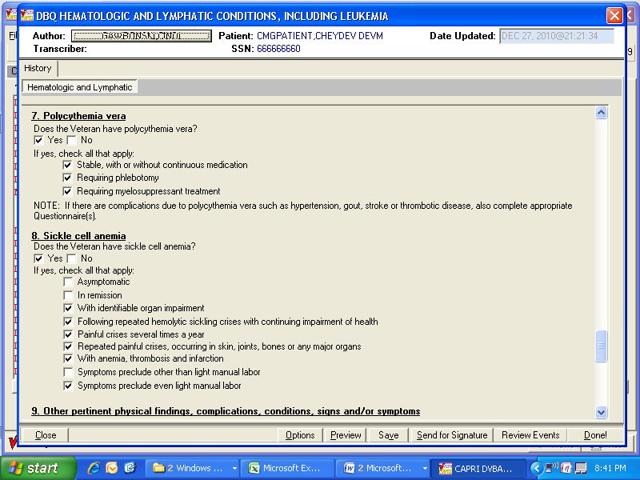

Figure 18: Print Example: DBQ – Hemic and Lymphatic – 7. Polycythemia vera
7. Polycythemia vera
--------------------
Does the Veteran have polycythemia vera?
[X] Yes [ ] No
If yes, check all that apply:
[X] Stable, with or without continuous medication
[X] Requiring phlebotomy
[X] Requiring myelosuppressant treatment
NOTE: If there are complications due to polycythemia vera such as
hypertension, gout, stroke or thrombotic disease, also complete
appropriate Questionnaire(s).

Section 8. Sickle cell anemia
All questions in this section may be answered as described by the rules below. If all mandatory questions are not answered, the error message(s) will appear in a popup window as depicted below.

Table 9: Rules: DBQ – Hemic and Lymphatic – 8. Sickle cell anemia
Field/Question | Field Disposition | Valid Values | Format | Error Message
8. Sickle cell anemia | If Condition = Sickle cell anemia; Enabled, Read-Only  Else; Disabled | N/A | N/A | N/A
Does the Veteran have sickle cell anemia? | If Condition = Sickle cell anemia; Enabled, Mandatory, Choose one valid value  Else; Disabled | [Yes; No] | N/A | Please answer the question: Does the Veteran have sickle cell anemia?
If yes, check all that apply: | If Does the Veteran have sickle cell anemia? = Yes; Enabled, Mandatory  Else; Disabled | [Asymptomatic;  In remission;  With identifiable organ impairment;  Following repeated hemolytic sickling crises with continuing impairment of health;  Painful crises several times a year;  Repeated painful crises, occurring in skin, joints, bones or any major organs;  With anemia, thrombosis and infarction;  Symptoms preclude other than light manual labor ;  Symptoms preclude even light manual labor] | N/A | Please check all applicable statements regarding the Veteran's sickle cell anemia.

Figure 19: Template Example: DBQ – Hemic and Lymphatic – 8. Sickle cell anemia

Figure 20: Print Example: DBQ – Hemic and Lymphatic – 8. Sickle cell anemia
8. Sickle cell anemia
---------------------
Does the Veteran have sickle cell anemia?
[X] Yes [ ] No
If yes, check all that apply:
[ ] Asymptomatic
[ ] In remission
[X] With identifiable organ impairment
[X] Following repeated hemolytic sickling crises with continuing
impairment of health
[X] Painful crises several times a year
[X] Repeated painful crises, occurring in skin, joints, bones or any
major organs
[X] With anemia, thrombosis and infarction
[ ] Symptoms preclude other than light manual labor
[X] Symptoms preclude even light manual labor

Section 9. Other pertinent physical findings, complications, conditions, signs and/or symptoms
All questions in this section may be answered as described by the rules below. If all mandatory questions are not answered, the error message(s) will appear in a popup window as depicted below.

Table 10: Rules: DBQ – Hemic and Lymphatic – 9. Other pertinent physical findings, complications, conditions, signs and/or symptoms
Field/Question | Field Disposition | Valid Values | Format | Error Message
9. Other pertinent physical findings, complications, conditions, signs and/or symptoms | Enabled, Read-Only | N/A | N/A | N/A
a. Does the Veteran have any other pertinent physical findings, complications, conditions, signs and/or symptoms? | If Diagnosis = Yes and a condition is selected in the Diagnosis section; Enabled, Mandatory, Choose one valid value  Else; Enabled, Optional | [Yes; No] | N/A | Please answer the question: Does the Veteran have any other pertinent physical findings, complications, conditions, signs and/or symptoms?
If yes, describe(brief summary): | If Does the Veteran have any other pertinent physical findings, complications, conditions, signs and/or symptoms= Yes; Enabled, Mandatory  Else; Disabled | N/A | Free Text | Please describe any other pertinent physical findings, complications, conditions, signs and/or symptoms.
b. Does the Veteran have any scars (surgical or otherwise) related to any conditions or to the treatment of any conditions listed in the Diagnosis section above? | If Does the Veteran have any other pertinent physical findings, complications, conditions, signs and/or symptoms= Yes; Enabled, Mandatory  Else; Disabled | [Yes; No] | N/A | Please answer the question: Does the Veteran have any scars (surgical or otherwise) related to any conditions or to the treatment of any conditions listed in the Diagnosis section?
If yes, also complete a Scars Questionnaire for each scar. | Disabled; Read-Only | N/A | N/A | N/A

Figure 21: Template Example: DBQ – Hemic and Lymphatic – 9. Other pertinent physical findings, complications, conditions, signs and/or symptoms
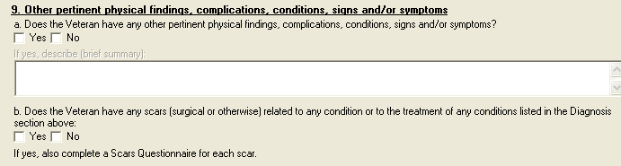

Figure 22: Print Example: DBQ – Hemic and Lymphatic – 9. Other pertinent physical findings, complications, conditions, signs and/or symptoms
9. Other pertinent physical findings, complications, conditions, signs
and/or symptoms
----------------------------------------------------------------------
Does the Veteran have any other pertinent physical findings, complications,
conditions, signs and/or symptoms?
[X] Yes [ ] No
If yes, describe (brief summary): Other pertinent findings will be
entered here

b. Does the Veteran have any scars (surgical or otherwise) related to any
conditions or to the treatment of any conditions listed in the Diagnosis
section above?
[ ] Yes [ ] No

If yes, also complete a Scars Questionnaire for each scar.

Section 10. Diagnostic testing

All questions in this section may be answered as described by the rules below. If all mandatory questions are not answered, the error message(s) will appear in a popup window as depicted below.

Table 11: Rules: DBQ – Hemic and Lymphatic – 10. Diagnostic testing
Field/Question | Field Disposition | Valid Values | Format | Error Message
10. Diagnostic testing | Enabled, Read-Only | N/A | N/A | N/A
If testing has been performed and reflects Veteran’s current condition, no further testing is required.  Provide most recent CBC, hemoglobin level or platelet count appropriate to the Veteran’s condition: | Enabled, Read-Only | N/A | N/A | N/A
a. CBC: | Enabled, Optional | N/A | Free Text | N/A
Date: | If CBC is populated; Enabled, Mandatory  Else; Enabled, Optional | N/A | Free Text | Please enter the date the CBC test was performed.
b. Hemoglobin level (gm/100ml): | Enabled, Optional | N/A | Free Text | N/A
Date: | If Hemoglobin level is populated; Enabled, Mandatory  Else; Enabled, Optional | N/A | Free Text | Please enter the date the hemoglobin level test was performed.
c. Platelet count: | Enabled, Optional | N/A | Free Text | N/A
Date: | If Platelet count is populated; Enabled, Mandatory  Else; Enabled, Optional | N/A | Free Text | Please enter the date the platelet count test was performed.
d. Are there any other significant diagnostic test findings and/or results? | If Diagnosis = Yes and a condition is selected in the Diagnosis section; Enabled, Mandatory, Choose one valid value  Else; Enabled, Optional | [Yes; No] | N/A | Please answer the question: Are there any other significant diagnostic test findings and/or results?
If yes, provide type of test or procedure, date and results (brief summary): | If Are there any significant diagnostic test findings and/or results= Yes; Enabled, Mandatory  Else; Disabled | N/A | Free Text | Please provide the type of diagnostic test or procedure, the date and the results.

Figure 23: Template Example: DBQ – Hemic and Lymphatic – 10. Diagnostic testing
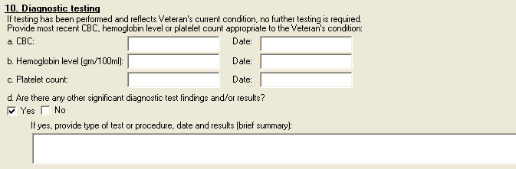

Figure 24: Print Example: DBQ – Hemic and Lymphatic – 10. Diagnostic testing
10. Diagnostic testing
----------------------
If testing has been performed and reflects Veteran's current condition, no further
testing is required.
Provide most recent CBC, hemoglobin level or platelet count appropriate to the
Veteran's condition:
a. CBC: Date:
b. Hemoglobin level (gm/100ml): Date:
c. Platelet count: Date:
d. Are there any other significant diagnostic test findings and/or results?
[ ] Yes [ ] No
If yes, provide type of test or procedure, date and results (brief
summary):

Section 11. Functional impact
All questions in this section may be answered as described by the rules below. If all mandatory questions are not answered, the error message(s) will appear in a popup window as depicted below.

Table 12: Rules: DBQ – Hemic and Lymphatic – 11. Functional impact
Field/Question | Field Disposition | Valid Values | Format | Error Message
11. Functional Impact | Enabled, Read-Only | N/A | N/A | N/A
Does the Veteran’s hematologic and/or lymphatic condition(s) impact his or her ability to work? | If Diagnosis = Yes and a condition is selected in the Diagnosis section; Enabled, Mandatory, Choose one valid value  Else; Enabled, Optional | [Yes; No] | N/A | Please answer the question: Does the Veteran's hematologic and/or lymphatic condition(s) impact his or her ability to work?
If yes, describe impact of each of the Veteran’s hematologic and/or lymphatic conditions, providing one or more examples: | If Does the Veteran’s hematologic and/or lymphatic condition(s) impact the Veteran’s ability to work = Yes; Enabled, Mandatory  Else; Disabled | N/A | Free Text | Please describe the impact of each hematologic and/or lymphatic condition on the Veteran's ability to work, providing one or more examples.

Figure 25: Template Example: DBQ – Hemic and Lymphatic – 11. Functional impact
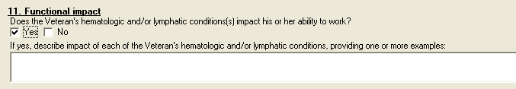

Figure 26: Print Example: DBQ – Hemic and Lymphatic – 11. Functional impact
11. Functional impact
---------------------
Does the Veteran's hematologic and/or lymphatic condition(s) impact his or
her ability to work?
[X] Yes [ ] No
If yes, describe impact of each of the Veteran's hematologic and/or
lymphatic conditions, providing one or more examples:

Section 12. Remarks, if any
All questions in this section may be answered as described by the rules below.

Table 13: Rules: DBQ – Hemic and Lymphatic – 12. Remarks, if any
Field/Question | Field Disposition | Valid Values | Format | Error Message
12. Remarks, if any | Enabled, Optional | N/A | Free Text | N/A

Figure 27: Template Example: DBQ – Hemic and Lymphatic – 12. Remarks, if any

Figure 28: Print Example: DBQ – Hemic and Lymphatic – 12. Remarks, if any
12. Remarks, if any:
--------------------

Hemic and Lymphatic DBQ-AMIE Worksheet
The DBQ-AMIE worksheets are accessed via the Print Blank C&P Worksheet menu [DVBA C PRINT BLANK C&P WORKSHE] option. Select the “DBQ HEMIC AND LYMPHATIC CONDITIONS INCLUDING LEUKEMIA” worksheet. DBQ-AMIE worksheets should be sent to a printer.

Hematologic and Lymphatic Conditions
Including Leukemia
Disability Benefits Questionnaire

Name of patient/Veteran: _______________________ SSN: ________________

Your patient is applying to the U. S. Department of Veterans Affairs
(VA) for disability benefits. VA will consider the information you
provide on this questionnaire as part of their evaluation in processing
the Veteran's claim.

1. Diagnosis

Does the Veteran now have or has he/she ever been diagnosed with a hematologic
and/or lymphatic condition?
___ Yes ___ No

If no, provide rationale (e.g., Veteran does not currently have any known
hematologic or lymphatic condition(s)): _____________________________________

If yes, select the Veteran's condition:

___ Acute lymphocytic leukemia (ALL)
ICD code: ________ Date of diagnosis: _____________
___ Acute myelogenous leukemia (AML)
ICD code: ________ Date of diagnosis: _____________
___ Chronic myelogenous leukemia (CML)
ICD code: ________ Date of diagnosis: _____________
___ Hodgkin's disease
ICD code: ________ Date of diagnosis: _____________
___ Non-Hodgkin's lymphoma
ICD code: ________ Date of diagnosis: _____________
___ Anemia ICD code: ________ Date of diagnosis: _____________
___ Thrombocytopenia
ICD code: ________ Date of diagnosis: _____________
___ Polycythemia vera
ICD code: ________ Date of diagnosis: _____________
___ Sickle cell anemia
ICD code: ________ Date of diagnosis: _____________
___ Splenectomy ICD code: ________ Date of diagnosis: _____________
___ Hairy cell and other B-cell leukemia: If checked, complete Hairy
cell and other B-cell leukemias Questionnaire.

___ Other hematologic or lymphatic condition(s):
Other diagnosis #1: ___________________
ICD code: _____________________________
Date of diagnosis: ____________________

Other diagnosis #2: ___________________
ICD code: _____________________________
Date of diagnosis: ____________________

Page: 2

Disability Benefits Questionnaire for
Hematologic and Lymphatic Conditions

Other diagnosis #3: ___________________
ICD code: _____________________________
Date of diagnosis: ____________________

If there are additional diagnoses that pertain to hematologic or lymphatic
condition(s), list using above format: ______________________________________

2. Medical history

a. Describe the history (including onset, course and status) of the
Veteran's current condition(s) (brief summary):______________________________

_____________________________________________________________________________

b. Indicate the status of the primary condition:
___ Active
___ Remission
___ Not applicable

3. Treatment

a. Has the Veteran completed any treatment or is the Veteran currently
undergoing any treatment for any lymphatic or hematologic condition,
including leukemia?
___ Yes ___ No; watchful waiting

If yes, indicate treatment type(s) (check all that apply):

___ Treatment completed; currently in watchful waiting status
___ Bone marrow transplant
If checked, provide:
Date of hospital admission and location: ____________________________
Date of hospital discharge after transplant: _________________________
___ Surgery
If checked, describe: ________________________________________________
Date(s)of surgery: _______________________
___ Radiation therapy
Date of most recent treatment: ___________
Date of completion of treatment or anticipated date of completion:____
___ Antineoplastic chemotherapy
Date of most recent treatment:____________
Date of completion of treatment or anticipated date of
completion:__________________
___ Other therapeutic procedure and/or treatment (describe):______________
______________________________________________________________________
Date of procedure:___________
Date of completion of treatment or anticipated date of
completion: _________________

Page: 3

Disability Benefits Questionnaire for
Hematologic and Lymphatic Conditions

b. Does the Veteran have anemia, including anemia caused by treatment for
a hematologic or lymphatic condition?
___ Yes ___ No (if "yes", answer both question 3.b.i and 3.b.ii)

i. Is the anemia caused secondary to treatment of another hematologic or
lymphatic condition?
___ Yes ___ No
If yes, provide the name of the other condition: ____________________
ii. Is continuous medication required for control of the anemia?
___ Yes ___ No
If yes, list medication(s): _________________________________________

c. Does the Veteran have thrombocytopenia, including thrombocytopenia
caused by treatment for a hematologic or lymphatic condition?
___ Yes ___ No (if "yes", answer both question 3.c.i and 3.c.ii)

i. Is the thrombocytopenia caused secondary to treatment of another
hematologic or lymphatic condition?
___ Yes ___ No
If yes, provide the name of the other condition: _____________________
ii. Is continuous medication required for control of the thrombocytopenia?
___ Yes ___ No
If yes, list medication(s): __________________________________________

4. Conditions, complications and/or residuals

a. Does the Veteran currently have any conditions, complications and/or
residuals due to a hematologic or lymphatic disorder or due to treatment
for a hematologic or lymphatic disorder?
___ Yes ___ No
If yes, check all that apply:
___ Weakness
___ Easy fatigability
___ Light-headedness
___ Shortness of breath
___ Headaches
___ Dyspnea on mild exertion
___ Dyspnea at rest
___ Tachycardia
___ Syncope
___ Cardiomegaly
___ High output congestive heart failure
___ Complications or residuals of treatment requiring transfusion of
platelets or red blood cells
If checked, indicate frequency:
___ At least once per year but less than once every 3 months
___ At least once every 3 months
___ At least once every 6 weeks

Page: 4

Disability Benefits Questionnaire for
Hematologic and Lymphatic Conditions

b. Does the Veteran currently have any other conditions, complications and/or
residuals of treatment from a hematologic or lymphatic disorder?
___ Yes ___ No

If yes, describe (brief summary): ___________________________________________

5. Recurring infections

Does the Veteran currently have any conditions, complications and/or
residuals of treatment for a hematologic or lymphatic disorder that result
in recurring infections?
___ Yes ___ No

If yes, indicate frequency of infections:
___ Less than once per year
___ At least once per year but less than once every 3 months
___ At least once every 3 months
___ At least once every 6 weeks

6. Thrombocytopenia (primary, idiopathic or immune)

Does the Veteran have thrombocytopenia?
___ Yes ___ No

If yes, check all that apply:
___ Stable platelet count of 100,000 or more
___ Stable platelet count between 70,000 and 100,000
___ Platelet count between 20,000 and 70,000
___ Platelet count of less than 20,000
___ With active bleeding
___ Requiring treatment with medication
___ Requiring treatment with transfusions

7. Polycythemia vera

Does the Veteran have polycythemia vera?
___ Yes ___ No

If yes, check all that apply:
___ Stable, with or without continuous medication
___ Requiring phlebotomy
___ Requiring myelosuppressant treatment

NOTE: If there are complications due to polycythemia vera such as
hypertension, gout, stroke or thrombotic disease, also complete appropriate
Questionnaire(s).

Page: 5

Disability Benefits Questionnaire for
Hematologic and Lymphatic Conditions

8. Sickle cell anemia

Does the Veteran have sickle cell anemia?
___ Yes ___ No

If yes, check all that apply:
___ Asymptomatic
___ In remission
___ With identifiable organ impairment
___ Following repeated hemolytic sickling crises with continuing
impairment of health
___ Painful crises several times a year
___ Repeated painful crises, occurring in skin, joints, bones or any
major organs
___ With anemia, thrombosis and infarction
___ Symptoms preclude other than light manual labor
___ Symptoms preclude even light manual labor

9. Other pertinent physical findings, complications, conditions, signs
and/or symptoms

a. Does the Veteran have any other pertinent physical findings,
complications, conditions, signs and/or symptoms?
___ Yes ___ No

If yes, describe (brief summary): ___________________________________________

b. Does the Veteran have any scars (surgical or otherwise) related to any
conditions or to the treatment of any conditions listed in the Diagnosis
section above?
___ Yes ___ No

If yes, also complete a Scars Questionnaire for each scar.

10. Diagnostic testing

If testing has been performed and reflects Veteran's current condition, no
further testing is required.
Provide most recent CBC, hemoglobin level or platelet count appropriate to
the Veteran's condition:

a. CBC: _____________________________________ Date: __________________

b. Hemoglobin level (gm/100ml):______________ Date: __________________

c. Platelet count: __________________________ Date: __________________

Page: 6

Disability Benefits Questionnaire for
Hematologic and Lymphatic Conditions

d. Are there any other significant diagnostic test findings and/or results?
___ Yes ___ No

If yes, provide type of test or procedure, date and results (brief
summary): _______________________________________________________________

11. Functional impact

Does the Veteran's hematologic and/or lymphatic condition(s) impact his or
her ability to work?
___ Yes ___ No

If yes, describe impact of each of the Veteran's hematologic and/or
lymphatic conditions, providing one or more examples: _______________________

12. Remarks, if any:_________________________________________________________

_____________________________________________________________________________

Physician signature: _____________________________________ Date: ____________

Physician printed name: __________________________________ Phone: ___________

Medical license #: _______________________________________ Fax: _____________

Physician address: __________________________________________________________

NOTE: VA may request additional medical information, including additional
examinations if necessary to complete VA's review of the Veteran's
application.

